**Ants on a Log** 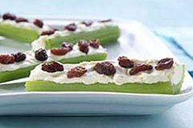

**what you need**

8 stalks  celery, each cut crosswise into 3 pieces

1 tub  (8 oz.) PHILADELPHIA Honey Pecan Cream Cheese Spread

½ cup  raisins or craisins

**make it**

**FILL**celery with cream cheese spread.

**TOP**with raisins.

**kitchens tips**

**SUBSTITUTE**

Prepare using plain PHILADELPHIA Cream Cheese Spread.

**Cereal Necklace**

Cereal Necklace - Yum!

Items you need:  
  
Yarn  
Cereal, Fruit Loops, Cheerio's, anything that is donut shaped.  
Tape  
  
Measure out your yarn to give your child a nice necklace. This will be different for each child, due to their size. Next I take and tape off one end of the yarn to keep it from unraveling. On the other end tie on a piece of cereal to keep them from being strung all the way off. After all that is done. Let your child go to it. String the Cereal. Soon you will have a beautiful necklace. Best of all your child can EAT it when they are done. This is a good activity to do before going on an outing. Then your child will have their snack right there with them the whole time.

|  |  |
| --- | --- |
| ENGLISH MUFFIN PIZZA: 10 EASY STEPS |  |
| Tin foil (No mess in oven or toaster oven when you use) English Muffins Pizza Sauce Cheese (mozzarella is best) Pepperoni (or any other desired toppings)  *This recipe MAY need parental supervision!*  1) Lay a square of aluminum foil in oven or toaster oven. 2) Preheat oven or toaster oven to 350°F. 3) Split English Muffins (may have to defrost if frozen). 4) Spread desired amount of pizza sauce on muffins. 5) Sprinkle cheese over sauce. 6) Put muffins in oven or toaster oven and bake for 3 minutes. 7) Take out 'pizza' (HOT!) and put your toppings on, if you want, add some more cheese. (Keep oven door closed.) 8) Return to the oven or toaster oven and bake for another 4 minutes. 9) Remove 'pizza' from oven and let cool for at least 1 minute. 10) Enjoy!! (Don't forget to turn off the oven or toaster oven and clean up!) | |

Grinch Treats

The Grinch thought it marvelous that he could disguise himself so easily with a quick Santy Claus hat and coat. There’s no great Grinchy trick at work here—these treats are both delicious and good for you!

What you’ll need:

* a bunch of large green grapes
* fresh strawberries and/or fresh raspberries
* bananas
* apples
* 2 tablespoons of cream cheese
* 4-6 tablespoons confectioners sugar
* juice from half a small lemon
* toothpicks or small skewers
* an icing bag or a non-pleated closable plastic sandwich bag
* Dr. Seuss’s [*How the Grinch Stole Christmas!*](http://www.seussville.com/books/book_detail.php?isbn=9780375838477)

Directions:

There are a couple of options for transforming the Grinch—a green grape—into Santa Claus:

* **Fruit kabob**: Wash the grapes and strawberries and dry thoroughly. Cut the tops off strawberries and slice a banana. (Squeeze some lemon juice on banana slices to prevent browning.) Load a toothpick or skewer with a grape. Top it with a banana slice and then a strawberry. Now your green grape Grinch has a lovely banana-trimmed red strawberry Santa Claus hat!
* **Hors d'oeuvres**: Wash an apple, grapes and raspberries and dry thoroughly. Cut the apple in half and place the halves flat side down on a plate. While the other fruit is draining, mix up the cream cheese, confectioners sugar and about a teaspoon of lemon juice. Blend until smooth and fairly thick. Put the icing in an icing bag with a small tip or cut a small corner from a plastic sandwich bag.

Put a grape on a toothpick and add a raspberry so it fits closely over the top of the grape. Use your icing bag to pipe white trim around the bottom of the raspberry and add a small dollop on the very top of the berry for the hat’s pompom. To let the icing dry (and for serving a lot of these appetizers at one time), push the bottom end of the toothpick into an apple half.

Either or both options are fun in the kitchen for kids and the perfect snack to munch while listening to you read aloud *How the Grinch Stole Christmas!*

Fruity solar system recipe

Making this fruity solar system is the perfect way to teach kids about the planets and where they are positioned in the universe. Best of all, they get to eat it in the end too.

**Category:**

[After school snacks](http://www.kidspot.com.au/best-recipes/After-school-snacks+86.htm), [Fruit](http://www.kidspot.com.au/best-recipes/Fruit+71.htm), [Kids cooking](http://www.kidspot.com.au/best-recipes/Kids-cooking+5.htm), [Kids food](http://www.kidspot.com.au/best-recipes/Kids-food+26.htm), [Snacks](http://www.kidspot.com.au/best-recipes/Snacks+13.htm)

**Ingredients:**

* 1 orange
* 1 punnet cherry tomatoes
* 1 punnet strawberries
* 1 banana
* 1 x 50g tin corn kernels, drained
* 3 x Mini Babybel cheese
* 1 punnet blueberries
* 1 small bunch green grapes
* 1 x blue plate

**Method:**

**Sun:** orange slice

**Mars:** cherry tomato slice

**Venus:** strawberry slice

**Earth**: banana slice

**Mercury**: corn kernel

**Jupiter:** Mini Babybel cheese, wrapper removed

**Neptune:** blueberry

**Uranus:** grape

**Saturn:** Mini Babybel cheese, wrapper partially removed

**Asteroid belt:** Mini Babybel cheese, unwrapped and broken into pieces

On the blue plate, arrange the preceding items into the formation according to the planets map.

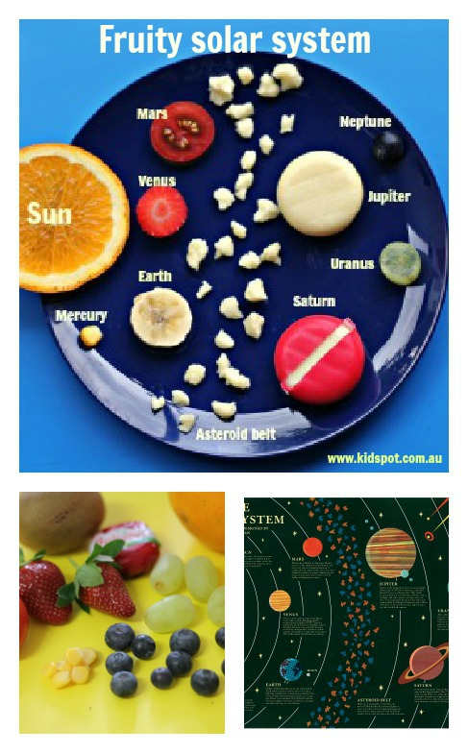

**Notes:**

* This is a great activity to do with kids when they are learning about space.
* You can vary the fruits with vegetables and just use what you have in the crisper.

***Carrot Curl Chips***

Yield: 2 cups (approximate volume)

Active Time: 15 minutes  
Total Time: 1 hour, 15 minutes

2 large carrots, sliced into long ribbons with a vegetable peeler  
2 tsp. olive oil  
1/2 tsp. curry powder  
1/4 tsp. salt

1) Preheat the oven to 200 F / 93 C.  
2) Gently toss all of the ingredients together, ensuring the surface area of each carrot ribbon is evenly coated.  
3) Lightly grease a clean metal cooling rack, and place each carrot ribbon in a flat, single layer. Allow the ribbons to dip slightly in between each bar to create a wavy effect.  
4) Bake for 1 1/2 hours until crispy and gently remove from rack.

[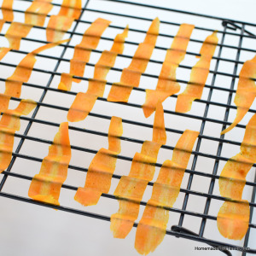](http://homemadeforfriends.files.wordpress.com/2014/03/4-3-dsc_0905.jpg)

Grape caterpillars recipe

These cute little green grape caterpillars tick all the boxes when it comes to healthy and easy. Pop them into lunch boxes, serve them up at parties or keep them in the fridge for a tasty snack.

**Category:**

[After school snacks](http://www.kidspot.com.au/best-recipes/After-school-snacks+86.htm), [Budget](http://www.kidspot.com.au/best-recipes/Budget+23.htm), [Easy recipes](http://www.kidspot.com.au/best-recipes/Easy-recipes+15.htm), [Fruit](http://www.kidspot.com.au/best-recipes/Fruit+71.htm), [Healthy](http://www.kidspot.com.au/best-recipes/Healthy+25.htm),[Kids cooking](http://www.kidspot.com.au/best-recipes/Kids-cooking+5.htm), [Kids food](http://www.kidspot.com.au/best-recipes/Kids-food+26.htm), [Lunch box](http://www.kidspot.com.au/best-recipes/Lunch-box+10.htm), [Party food](http://www.kidspot.com.au/best-recipes/Party-food+11.htm)

**Ingredients:**

* 300g green grapes
* short wooden skewers
* 1 x 50g tube writing fudge, white chocolate
* mini milk choc bits

**Method:**

**Step 1.** Remove grapes from stalks, wash and dry well.

**Step 2.** Thread grapes onto skewers.

**Step 3**. Trim points from skewers with scissors.

**Step 4**. Dot writing icing onto the back of the coated chocolate chips and place as eyes on each caterpillar.

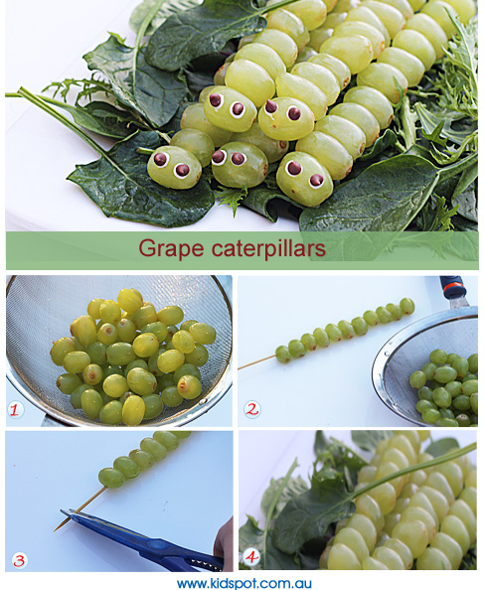

**Notes:**

* To serve these for parties, you can lay them on a bed of lettuce.
* Make sure you trim off the sharp tips of the skewers. Especially if serving these to small children.

Strawberry mice recipe

Looking for some party food for toddlers? These delicious strawberry mice are a great healthy choice and cute to boot!

**Category:**

[After school snacks](http://www.kidspot.com.au/best-recipes/After-school-snacks+86.htm), [Healthy](http://www.kidspot.com.au/best-recipes/Healthy+25.htm), [Kids cooking](http://www.kidspot.com.au/best-recipes/Kids-cooking+5.htm), [Kids food](http://www.kidspot.com.au/best-recipes/Kids-food+26.htm), [Party food](http://www.kidspot.com.au/best-recipes/Party-food+11.htm)

**Prep Time:**

5 mins

**Cook Time:**

0 mins

**Ingredients:**

* 1 punnet strawberries
* black writing icing
* 1/4 cup mini chocolate chips
* 1/4 cup almond flakes
* 2 straps raspberry licorice
* 100g Swiss cheese

**Method:**

**Step 1.** Remove the green stems from each strawberry. Slice a small slice from one side of each strawberry so it will sit flat on the plate.

**Step 2**. Use the black writing icing to stick a choc chip on the pointy end as a nose.

**Step 3.** Use the writing icing to create eyes. Poke 2 slots with a sharp knife and slide in 2 almond flakes as ears per mouse.

**Step 4.**Use a skewer to poke a hole into the berry and slide in the licorice as a tail. Cut the cheese into wedges and serve with the strawberry mice.

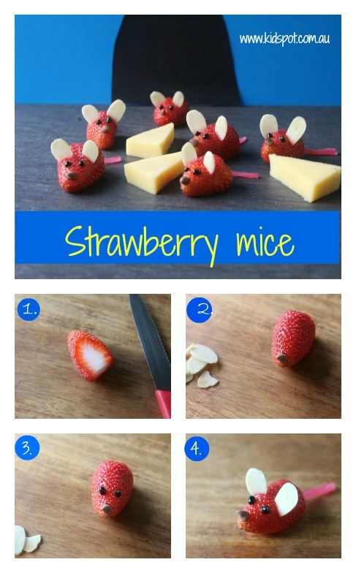

**YIELD: ABOUT 8 SERVINGS**

**RAINBOW VEGGIE FLATBREAD PIZZA**

***Taste the rainbow with this delicious and healthier Rainbow Veggie Flatbread Pizza recipe.*** 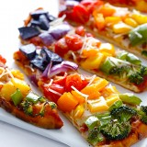

**PREP: 10 MINS COOK: 20 MINS TOTAL: 30 MINS**

**INGREDIENTS:**

* **1 package (2-piece) Stonefire naan**
* **1/2 cup pizza sauce, homemade**[**http://www.gimmesomeoven.com/perfect-pizza-sauce/**](http://www.gimmesomeoven.com/perfect-pizza-sauce/)**or store-bought**
* **1/2 cup shredded part-skim Mozzarella cheese**
* **about 4 cups chopped colorful veggies (I used broccoli florets, green peppers, yellow peppers, orange peppers, grape tomatoes, red onions and thinly-sliced purple potatoes)**
* **2 tsp. olive oil**
* **1 tsp. Italian seasonings**
* **(optional toppings: grated Parmesan cheese, red pepper flakes)**

**DIRECTIONS:**

**Preheat oven to 425 degrees F.**

**Lay out both pieces of naan in a single layer on a large baking sheet. Divide pizza sauce between the two pieces of naan, and use a spoon to spread it over the top of the naan. Sprinkle the cheese on top of the pizza sauce. Then layer the veggies in a rainbow pattern on top of the cheese. Drizzle or mist each pizza with a bit of olive oil. (I like to use a Misto**[**http://www.amazon.com/Misto-Brushed-Aluminum-Olive-Sprayer/dp/B00004SPZV**](http://www.amazon.com/Misto-Brushed-Aluminum-Olive-Sprayer/dp/B00004SPZV)**.) Then sprinkle each pizza with the Italian seasonings.**

**Bake for about 20 minutes, or until the veggies are cooked and the crust is slightly golden. Remove pizzas from oven, and sprinkle with optional toppings if desired. Slice and serve warm.**

**DIFFICULTY: EASY INGREDIENTS:**[**BROCCOLI**](http://www.gimmesomeoven.com/tag/broccoli/)**,**[**ITALIAN SEASONINGS**](http://www.gimmesomeoven.com/tag/italian-seasonings/)**,**[**MOZZARELLA**](http://www.gimmesomeoven.com/tag/mozzarella/)**,**[**NAAN**](http://www.gimmesomeoven.com/tag/naan/)**,**[**PARMESAN**](http://www.gimmesomeoven.com/tag/parmesan/)**,**[**PEPPERS**](http://www.gimmesomeoven.com/tag/peppers/)**,**[**PIZZA SAUCE**](http://www.gimmesomeoven.com/tag/pizza-sauce/)**,**[**RED ONIONS**](http://www.gimmesomeoven.com/tag/red-onions/)**,**[**TOMATOES**](http://www.gimmesomeoven.com/tag/tomatoes/)

**YIELD: 2-4 CUPS PIZZA SAUCE**

**PERFECT PIZZA SAUCE**

**PREP: 5 MINS COOK: 20 MINS TOTAL: 25 MINS**

**INGREDIENTS:**

* **1 (14.5 oz.) can tomato sauce**
* **3 Tbsp. tomato paste**
* **1 garlic clove, finely minced**
* **1 Tbsp. chopped fresh basil (or 1 tsp. dried basil)**
* **2 tsp. dried oregano**
* **1 tsp. onion powder**
* **1/2 tsp. dried marjoram**
* **1/2 tsp. kosher salt**
* **pinch of cayenne**
* **splash of red wine (optional)**

**DIRECTIONS:**

**Combine all ingredients in a small saucepan. Cook over medium heat until bubbles begin to rise (and pop) at the surface. Reduce heat, cover, and let simmer for another 15 minutes.**

**Serve warm. Or you can also freeze this to use later. (I love freezing it in ice cube trays so that you can choose how much you want to thaw and use later!)**

**DIFFICULTY: EASY INGREDIENTS:**[**CAYENNE**](http://www.gimmesomeoven.com/tag/cayenne/)**,**[**FRESH BASIL**](http://www.gimmesomeoven.com/tag/fresh-basil/)**,**[**GARLIC**](http://www.gimmesomeoven.com/tag/garlic/)**,**[**MARJORAM**](http://www.gimmesomeoven.com/tag/marjoram/)**,**[**ONION POWDER**](http://www.gimmesomeoven.com/tag/onion-powder/)**,**[**OREGANO**](http://www.gimmesomeoven.com/tag/oregano/)**,**[**RED WINE**](http://www.gimmesomeoven.com/tag/red-wine/)**,**[**TOMATO PASTE**](http://www.gimmesomeoven.com/tag/tomato-paste/)**,**[**TOMATO SAUCE**](http://www.gimmesomeoven.com/tag/tomato-sauce/)

The Very Hungry Caterpillar fruit snack recipe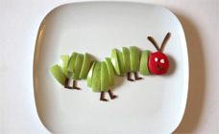

This snack, using the The Very Hungry Caterpillar book as inspiration, went down a treat in our house. Here apple is paired with Babybell cheese for a fun snack.

**Category:**

[After school snacks](http://www.kidspot.com.au/best-recipes/After-school-snacks+86.htm), [Fruit](http://www.kidspot.com.au/best-recipes/Fruit+71.htm), [Snacks](http://www.kidspot.com.au/best-recipes/Snacks+13.htm), [Toddler](http://www.kidspot.com.au/best-recipes/Toddler+14.htm)

**Ingredients:**

* 1 green apple, cut into slices
* 1 Babybel cheese (from the dairy aisle)
* 1 fruit strap (from the health food aisle)

**Method:**

Place the cheese onto the plate for the head.

Place the apple slices in a line to form the body. Leave one slice for the eyes.

Cut 6 little legs from the fruit strap using a small sharp knife. Place them underneath the body.

Cut a little smile for the face. Cut two antenae. Place smile onto the cheese and antenae above.

Cut two small eyes from the apple slice. Place onto the cheese.

**Notes**

* You can get your children to help you with this recipe. Give them a plastic knife and some apple pieces to chop while you prepare this snack.**y, family friendly recipes each week**

Top of Form

## Banana palm trees recipeBanana palm trees

These cute little banana palm trees are a great way to make fruit interesting for your kids. They will be so busy playing with the shapes that they’ll forget how healthy fruit is.

#### Category:

[After school snacks](http://www.kidspot.com.au/best-recipes/After-school-snacks+86.htm), [Easy recipes](http://www.kidspot.com.au/best-recipes/Easy-recipes+15.htm), [Fruit](http://www.kidspot.com.au/best-recipes/Fruit+71.htm), [Kids cooking](http://www.kidspot.com.au/best-recipes/Kids-cooking+5.htm), [Kids food](http://www.kidspot.com.au/best-recipes/Kids-food+26.htm), [Party food](http://www.kidspot.com.au/best-recipes/Party-food+11.htm)

#### Ingredients:

* 1 banana
* 1 mandarin
* 2 kiwi fruits

#### Method:

Peel the banana and cut it down the centre lengthways. On a chopping board cut each half into 1.5 cm slices. Slide your knife underneath the banana slices and place them onto the plate. Arrange them as two tree trunks.

Peel the mandarin, and separate the segments. On the plate, place the segments in rows below the banana to create an island.

Peel the skin off the kiwi fruit and cut into small segments. Place above the banana ‘tree trunks’ to look like palm leaves.

#### Notes:

* To encourage your children to eat more fruit, you can get them to help you make this recipe. Just give them a chopping board and a plastic knife and encourage them to eat any pieces they cut up

**Hearts and stars fruit salad**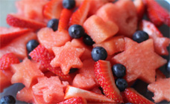

You can serve this fun fruit salad with yoghurt; put it on top of pancakes or just pop into lunch boxes with a fork. The kids will love helping to press out the shapes then eating them!

**Prep Time:**

10 mins

**Cook Time:**

0 mins

**Ingredients:**

* 1 seedless watermelon, whole
* 2 punnets strawberries
* 2 punnets blueberries

**Method:**

Slice the watermelon in half and then lay it cut side down on the chopping board. Carefully slice thin slices and then use cookie cutters to cut your shapes. Place in a serving bowl.

Cut the tops off the strawberries and slice. Place with the blueberries into the serving bowl.

Gently toss and serve with a nice thick dollop of Greek yoghurt and a sprinkle of muesli.

**Notes**

* You can use any cookie or even playdough cutters to make this. It is all about getting the kids involved and making food preparation fun.
* You can adjust this recipe to what you have in your fruit bowl. You just need to make sure that you use some type of melon so the kids can cut the shapes. Rockmelon and honeydew will work but you may have to use smaller cutters.
* I encouraged the kids to eat the leftover bits of fruit as we made this together.

Apple race car snacks recipe

Your little ones will love these cute mini race car snacks made out of apples and grapes. Catch one quick before they go!

**Serving Size:**

8

**Category:**

[2 Ingredient recipes](http://www.kidspot.com.au/best-recipes/2-Ingredient-recipes+148.htm), [After school snacks](http://www.kidspot.com.au/best-recipes/After-school-snacks+86.htm), [Fruit](http://www.kidspot.com.au/best-recipes/Fruit+71.htm), [Party food](http://www.kidspot.com.au/best-recipes/Party-food+11.htm)

**Prep Time:**

5 mins

**Ingredients:**

* 4 Jazz apples
* 16 green grapes, cut in half

**You will also need:**

* 16 toothpicks

**Method:**

Gather all ingredients. Cut two full cheeks from each apple. Slice out the centre third so you have a wedge.

Slip 2 toothpicks into each apple wedge to become the car axles. Place grape halves on each side of the toothpick for wheels. Vroom vroom!

